Name

Mathematics Stage 4
Area of Circles and Sectors

Book 1 | Develop and use the formula to find the area of circles and sectors to solve problems | Version: 260707  Feedback:  https://MrDingMaths.com
Contents
Syllabus Content 2
Area of a Circle 3
Area of a Sector 10
Mixed Practice 15
Composite Figures involving Circles 16
Finding the Radius Given the Area 22
Challenge Exercise 31

Syllabus Content
MA4-ARE-C-01 applies knowledge of area and composite area involving triangles, quadrilaterals and circles to solve problems
Develop and use the formula to find the area of circles and sectors to solve problems
- Develop and apply the formula to find the area of a circle: $A=πr^{2}$, where $r$ is the length of the radius
- Explain how the area of a sector can be developed from the area of a circle $A=\frac{θ}{360}×πr^{2}$
- Find the area of quadrants, semicircles and sectors, and apply these formulas in the context of real-life problems
- Calculate the areas of composite shapes involving quadrants, semicircles and sectors to solve problems

Area of a Circle

- Review
- Square numbers
- $4^{2}$ | - $8^{2}$ | - ${11}^{2}$ | - ${1.3}^{2}$

- Round decimals to 2 d.p.
- 78.539845 | - 153.938881 | - 28.27454 | - 95.03399

- Identify radius and diameter of circles
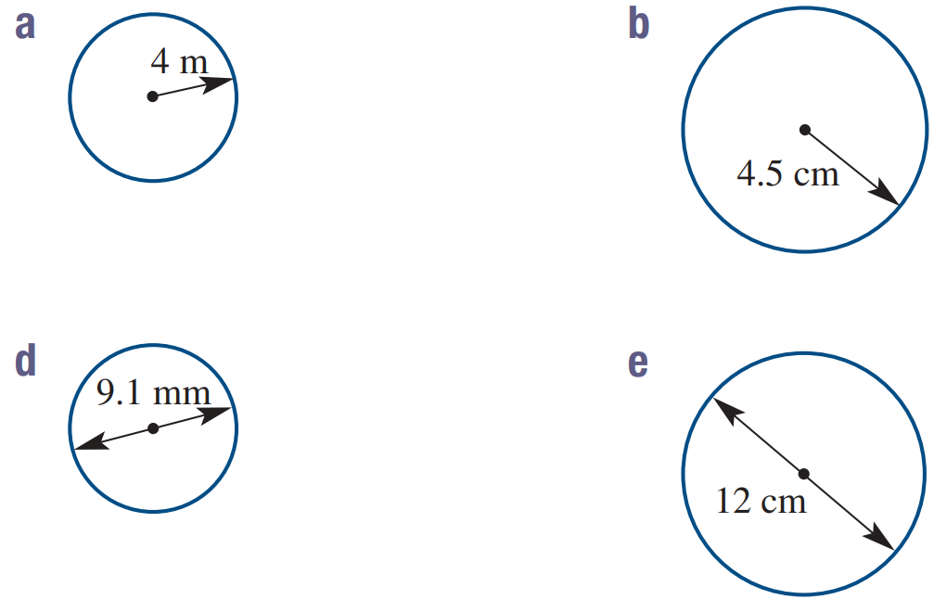  Radius: …………  Diameter: ………… | Radius: …………  Diameter: ………… | Radius: …………  Diameter: ………… | Radius: …………  Diameter: …………

- Investigation Area of a circle
- Area of a Circle: https://www.geogebra.org/m/fuwvtu7w
Consider a circle divided into sectors, then placed together into a shape that resembles a parallelogram.
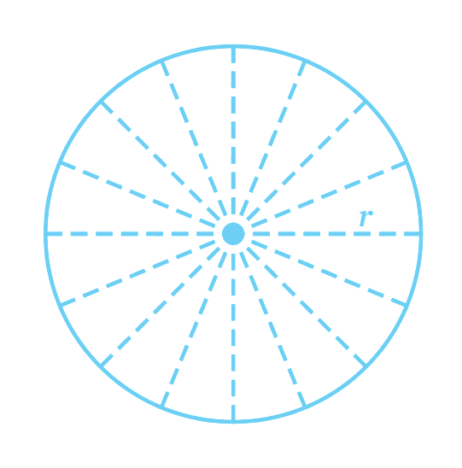
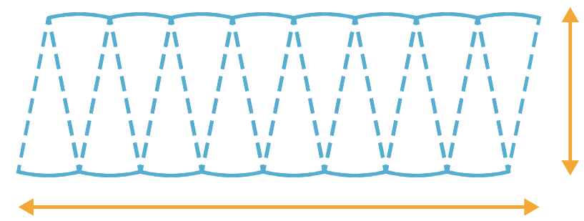

Label the base and height of the parallelogram, then calculate the area.

$$A=bh$$
$=$ ……… $×$ ………
$=$ …………………

- Area of a Circle
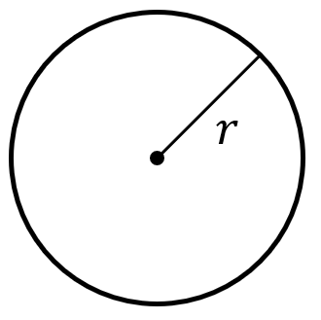
$$A=πr^{2}$$

radius

- Example Calculate area of a circle
Calculate the area of these circles. Answer to 2 decimal places.
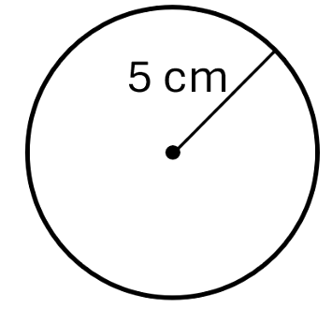  $A=πr^{2}$  $=π({5)}^{2}$  $=78.53981634…$  $≈78.54$ cm² | $A=πr^{2}$  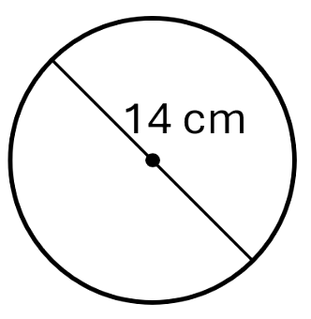  $=π({7)}^{2}$  $=153.93804…$  $≈153.94$ cm²

- Guided Practice
Calculate the area of these circles. Answer to 2 decimal places.
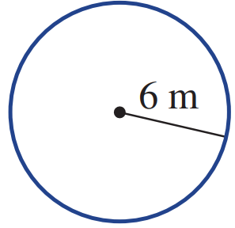  $A=πr^{2}$  $=$ $π{\left( \right)}^{2}$  $=$ ………………  113.10 m² | 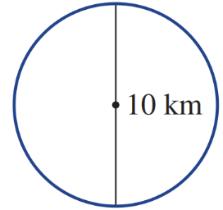  $A=πr^{2}$  $=$ $π{\left( \right)}^{2}$  $=$ ………………  78.54 km²
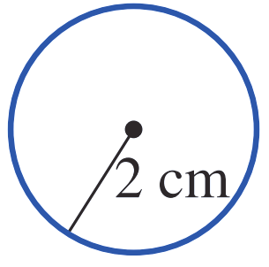  12.57 cm² | 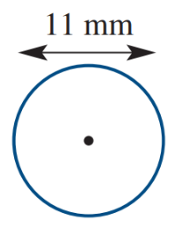  95.03 mm²

- Key Ideas
- We calculate the area of a circle using the formula ………………
- The formula always uses the …………………… of a circle
- If the diameter is given, we need to change it to ………………… by ……………… the diameter before doing any calculations.
- Interpret Exact form
Giving and exact answer in terms of $π$ means we do not press the $π$ button on the calculator.
Instead, we write the number multiplied by $π$.
For example:
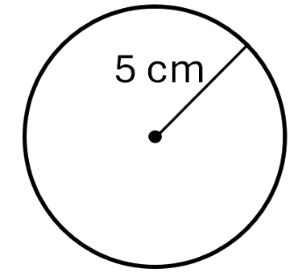 | Exact form  $$A=πr^{2} \\ =π{\left(5\right)}^{2} \\ =25π$$ | Rounded to 2 d.p.  $$A=πr^{2} \\ =π{\left(5\right)}^{2} \\ ≈78.54 {cm}^{2}$$
Find the exact area of these circles in terms of $π$.
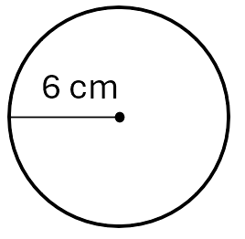 | 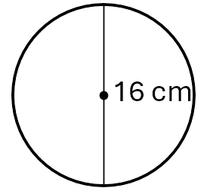 | 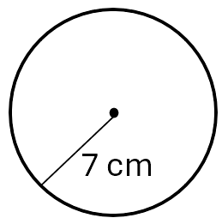
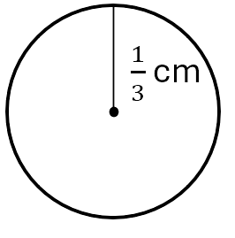 | 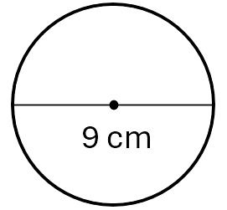 | 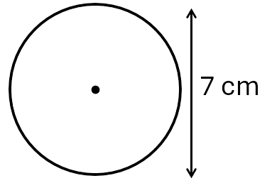

Foundation
- Calculate the area of these circles. Leave your answer in terms of $π$.
The first question has been done for you.
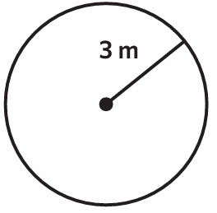  $$A=π{\left(3\right)}^{2}$$  $=9π m^{2}$ | 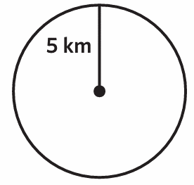  25π km² | 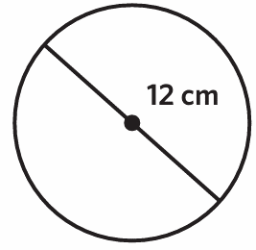  36π cm² | 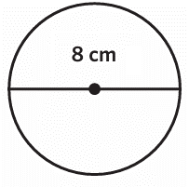  16π cm²

- Calculate the area of these circles correct to two decimal places.
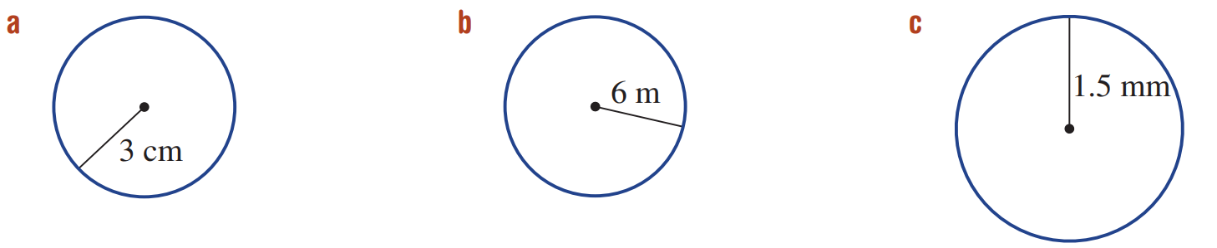  $A=πr^{2}$  $=π{\left( \right)}^{2}$  $=$ ……………  28.27 cm² | $A=πr^{2}$  $=$ ……………  $=$ ……………  113.10 m² | $A=πr^{2}$  $=$ ……………  $=$ ……………  7.07 mm²
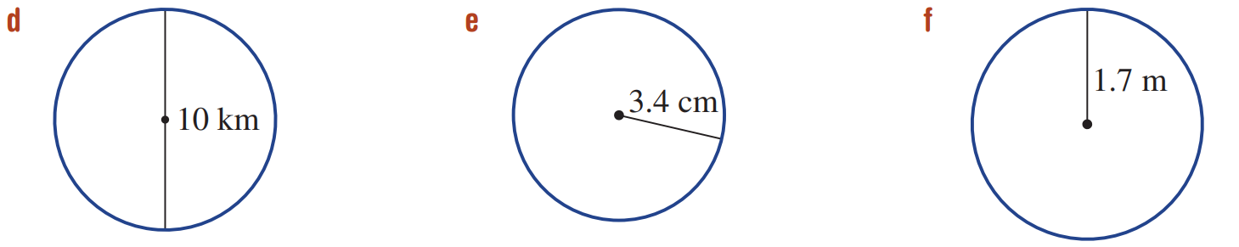  78.54 km² | 36.32 cm² | 9.08 m²
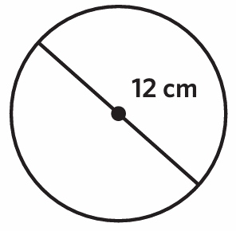  113.10 cm² | 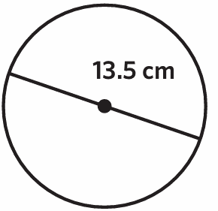  143.14 cm² | 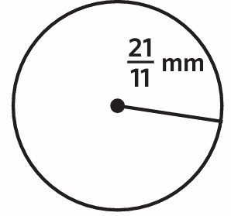  11.45 mm²

Development
- Calculate the area of these circles. Answer in exact form in terms of $π$.
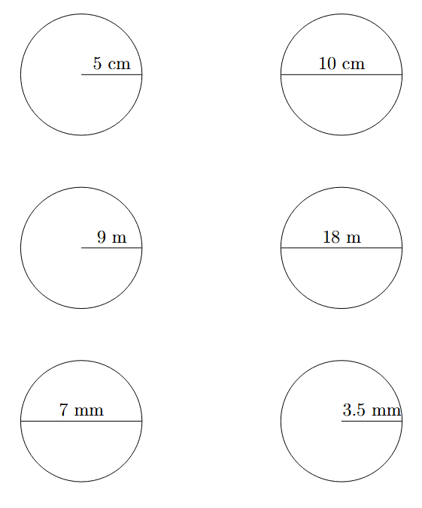  25π cm² | 25π cm² | 81π m²
81π m² | $$\frac{49π}{4} {mm}^{2}$$ | $$\frac{49π}{4} {mm}^{2}$$

- A pizza tray has a diameter of 30 cm. Calculate its area to the nearest whole number of cm²

707 cm²
- Two circular plates have radii 12 cm and 13 cm.
Find the difference in their area, correct to two decimal places.

78.54 cm²
- Find the area of the circle in terms of $π$ as a fraction.
$$\frac{16}{9}π {cm}^{2}$$ | 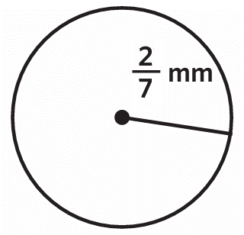  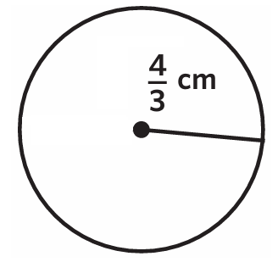  $$\frac{4}{49}π {mm}^{2}$$

- A tanker ship spills a circular oil slick 1 km in diameter.
The news reports that the area covered by the oil slick is over a square kilometre.
Are they correct?

No, they are incorrect. The area is only 0.785 km²
- Ed calculated the area of this circle as $49π$ m².
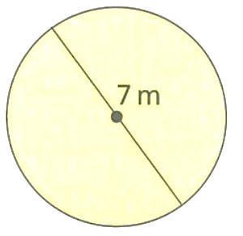
  - Explain why he is incorrect.

The radius is $\frac{7}{2}$, not 7
  - Write the correct area in terms of $π$ as a fraction

$$\frac{49}{4}π m^{2}$$
- A farmer uses a sprinkler that waters a circular area. The sprinkler reaches 12 m in every direction. Calculate the area watered, to the nearest m².

$$r = 12 m$$
$$A = π × 12² = 144π ≈ 452 m²$$
- A circular swimming pool has a diameter of 4.5 m.
Calculate the area of the pool surface to 2 d.p.

$$r = 4.5 ÷ 2 = 2.25 m$$
$$A = π × 2.25² ≈ 15.90 m²$$
- A circular table has radius 60 cm. A tablecloth must overhang by 15 cm on all sides. What is the area of the tablecloth to the nearest cm²? (Hint: find the radius of the tablecloth first.)

$$Tablecloth radius = 60 + 15 = 75 cm$$
$$A = π × 75² ≈ 17 671 cm²$$
- A circular mirror has diameter 55 cm. A square mirror has side length 55 cm. The shopkeeper says the circular mirror has more glass. Is she correct? Show your working.

Circular mirror: $A = π × 27.5² ≈ 2375.83 cm²$
Square mirror: $A = 55² = 3 025 cm²$
No, the square mirror has more glass.

- Pizza sizes are given using the diameter, measured in inches.
The 12-inch pizza is cut into 8 equal slices. Rayyan eats 3 slices.
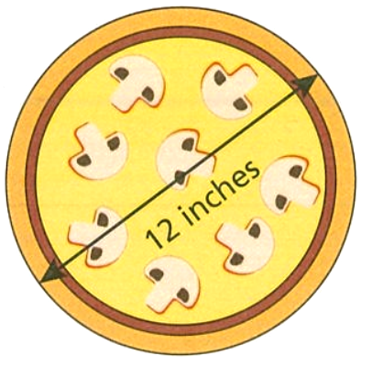
What is the area of the pizza that Rayyan ate? Answer in square inches to 1 d.p.

Whole pizza: $π{\left(6\right)}^{2}=36π {in}^{2}$
$$\frac{3}{8}×36π=\frac{27π}{2} {in}^{2}≈42.4 {in}^{2}$$

Mastery
- Find the area of these circles with given radius. Give exact answers in terms of π.
$r = 5$ cm → A = …………… cm²
$r = 10$ cm → A = …………… cm²
$r = 30$ cm → A = …………… cm²
$$r = 5 cm → A = 25π cm²$$
$$r = 10 cm → A = 100π cm²$$
$$r = 30 cm → A = 900π cm²$$
What happens to the area when you double the radius?
$$The area multiplies by 4 (since A = πr², doubling r gives π(2r)² = 4πr²).$$
What happens to the area when you triple the radius?
$$The area multiplies by 9 (since π(3r)² = 9πr²).$$

- You order a 9-inch pizza from a restaurant.
After a while, the waiter tells you that they no longer have 9-inch pizza bases and will instead give you two 5-inch pizzas instead.
He tries to convince you, saying that you will get more since $2×5=10$.
Explain to him why this is not a good deal.
Note: pizza sizes are measured according to the diameter.

9-inch pizza: $π{\left(4.5\right)}^{2}≈63.62 {in}^{2}$
2 5-inch pizzas: $π{\left(2.5\right)}^{2}×2≈39.27 {in}^{2}$
This is not a good deal as two 5-inch pizzas are significantly smaller than a single 9-inch pizza
(This happens because the radius gets squared; if you halve the radius, the area is a quarter, so giving two pizzas won’t make up the difference)

Area of a Sector

- Review
- Identify fraction of a circle shown
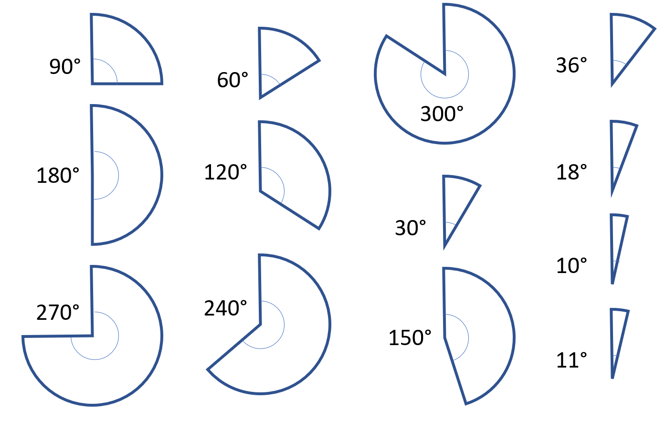

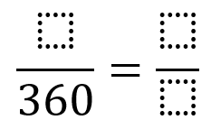

- Identify Interior angle of a sector
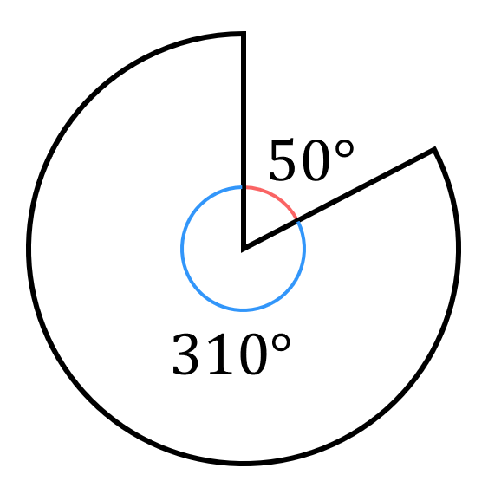
A sector is a part of a circle.
The interior angle of a sector is the angle inside the sector.
The interior angle and exterior angle must sum to 360°.

Identify the interior angle in these sectors
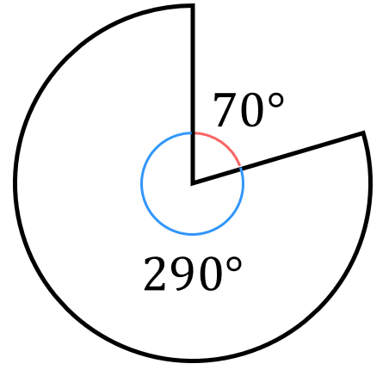 | 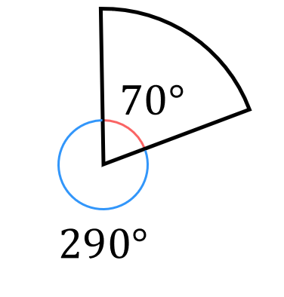 | 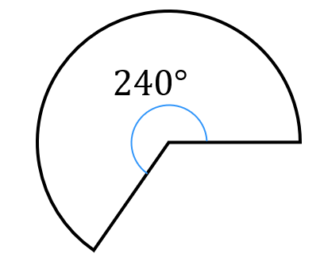
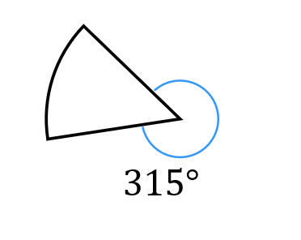 | 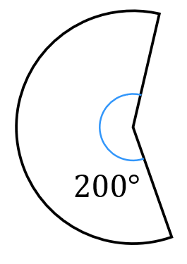 | 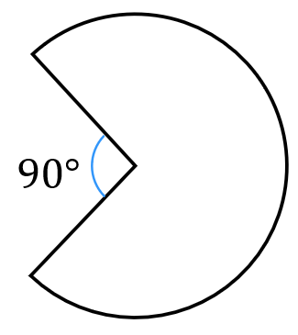
- Area of a Sector
A sector is a part of a circle.
The area of a sector is a fraction of the whole circle.
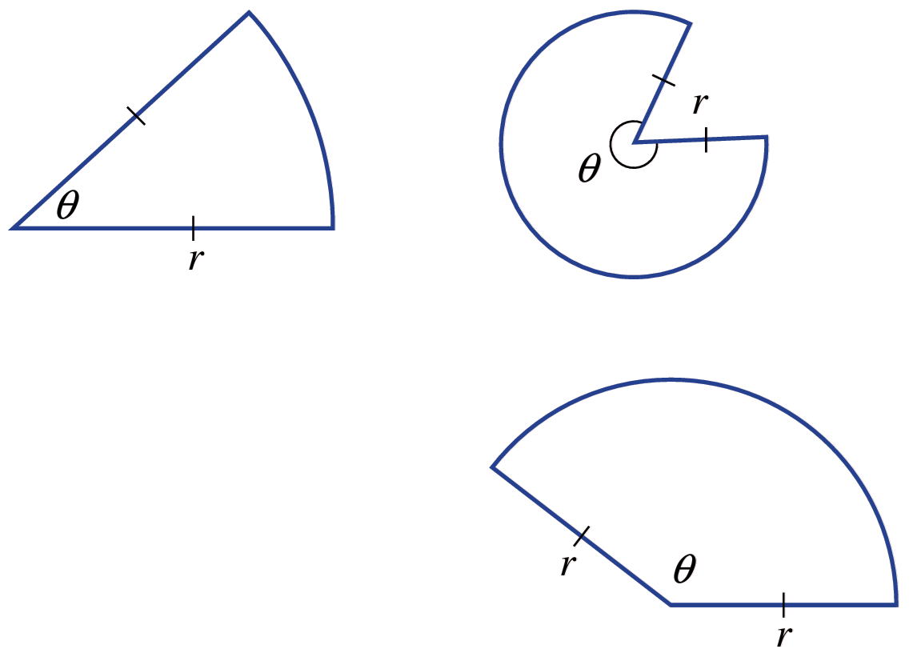
interior angle

$$A= \frac{θ}{360} × πr^{2}$$

fraction of area of whole
circle circle

- Example Calculate area of a sector
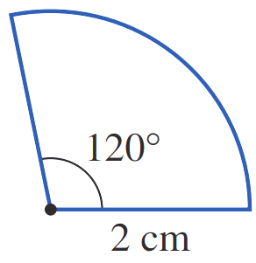
Calculate the area of these sectors. Answer to 2 decimal places.
$$A=\frac{θ}{360} πr^{2}$$  $$=\frac{120}{360}π{\left(2\right)}^{2}$$  $≈4.19$cm² | $A=$ $\frac{θ}{360}$ $πr^{2}$  $$=\frac{290}{360}π{\left(5\right)}^{2}$$  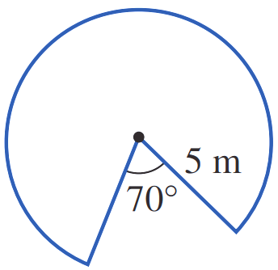  $≈63.27$m²

- Guided Practice
Calculate the area of these sectors to 2 decimal places.
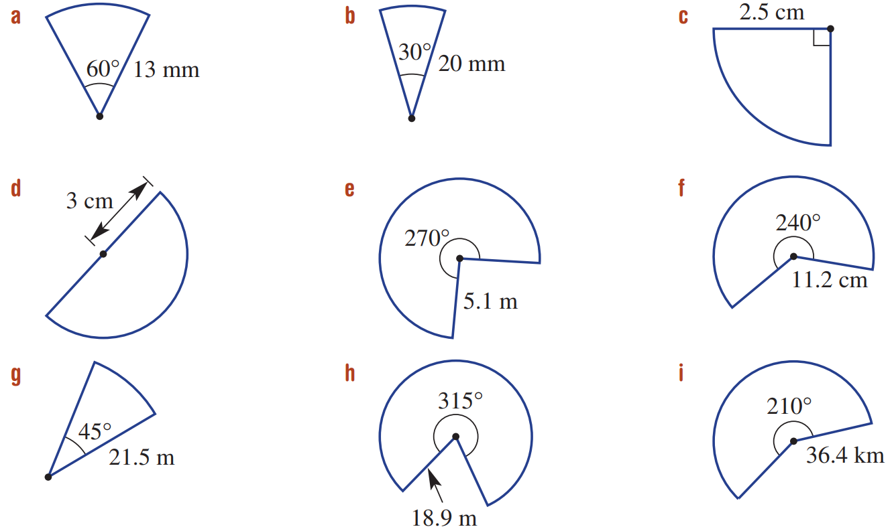  $A=$ $\frac{θ}{360}$ $πr^{2}$  $=$ …………………  $=$ …………………  88.49 mm² | $A=$ $\frac{θ}{360}$ $πr^{2}$  $=$ …………………  $=$ …………………  262.72 cm²
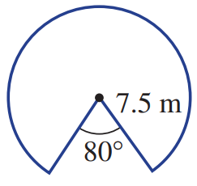  137.44 m² | 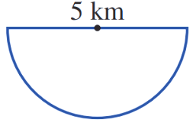  $=9.82$ km²

Foundation
- Identify the radius of these shapes.
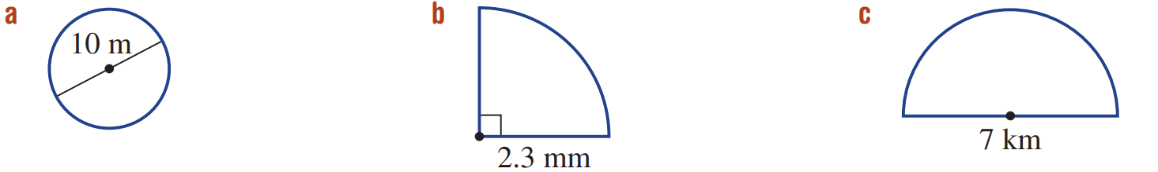  5 m | 2.3 mm | 3.5 km | 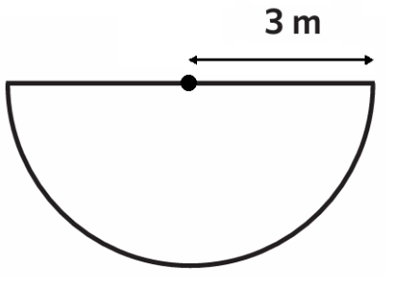  3 m

- Calculate the area of these parts of circles. Round to 2 d.p.
$$A=\frac{1}{4}πr^{2}$$  $$=\frac{1}{4}π{\left( \right)}^{2}$$  $=$ …………………  3.14 cm² | 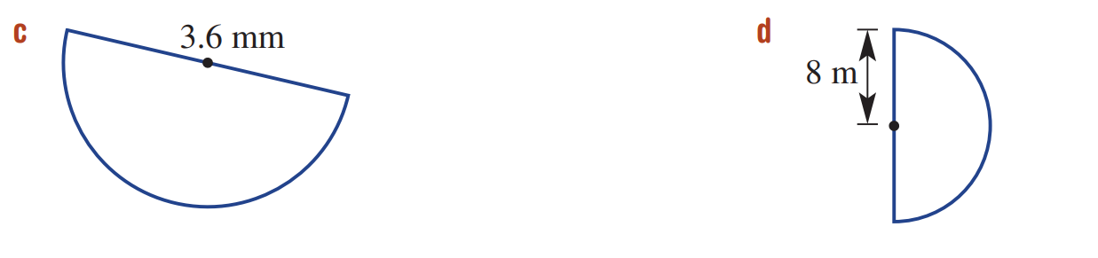  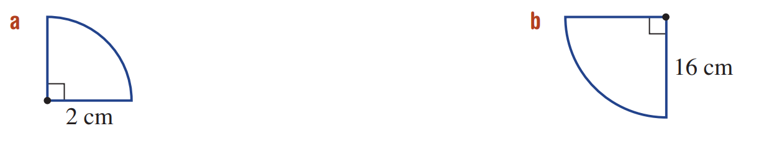  $$A=\frac{1}{2}πr^{2}$$  $$=\frac{1}{2}π{\left( \right)}^{2}$$  $=$ …………………  5.09 mm² |  | 201.06 cm² |  | 100.53 m²
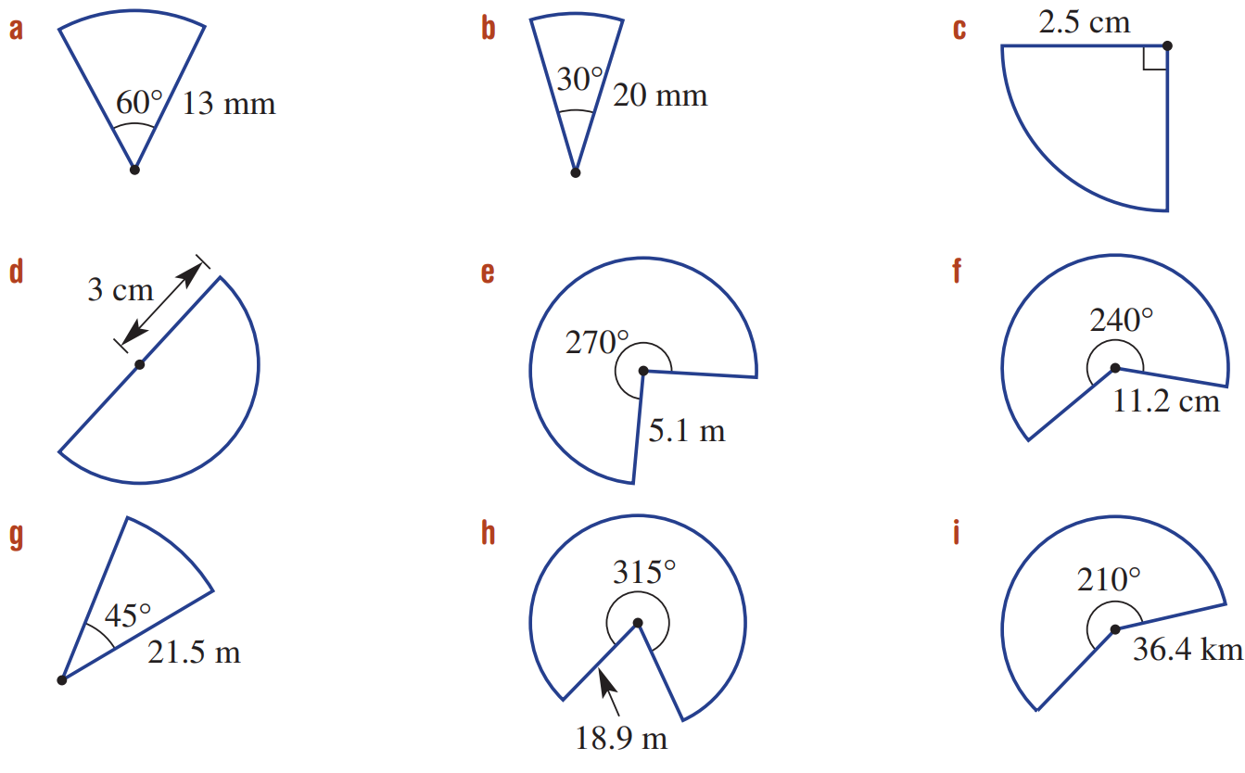  $$A=\frac{θ}{360}×πr^{2}$$  $$=\frac{}{360}×π{\left( \right)}^{2}$$  $=$ ………………………  104.7 mm² |  | 4.91 cm² |  | 181.5 m²
61.3 m² |  | 2428.1 km² |  | 981.9 m²

Development
- A simple bus wiper blade wipes an area over 100°, as shown.
Find the area wiped by the blade, correct to two decimal places.
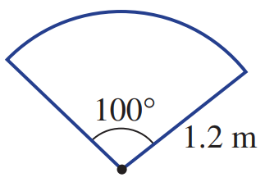

1.26 m²
- Calculate the area of each shape. Give your answers in terms of $π$.
The first has been done for you.
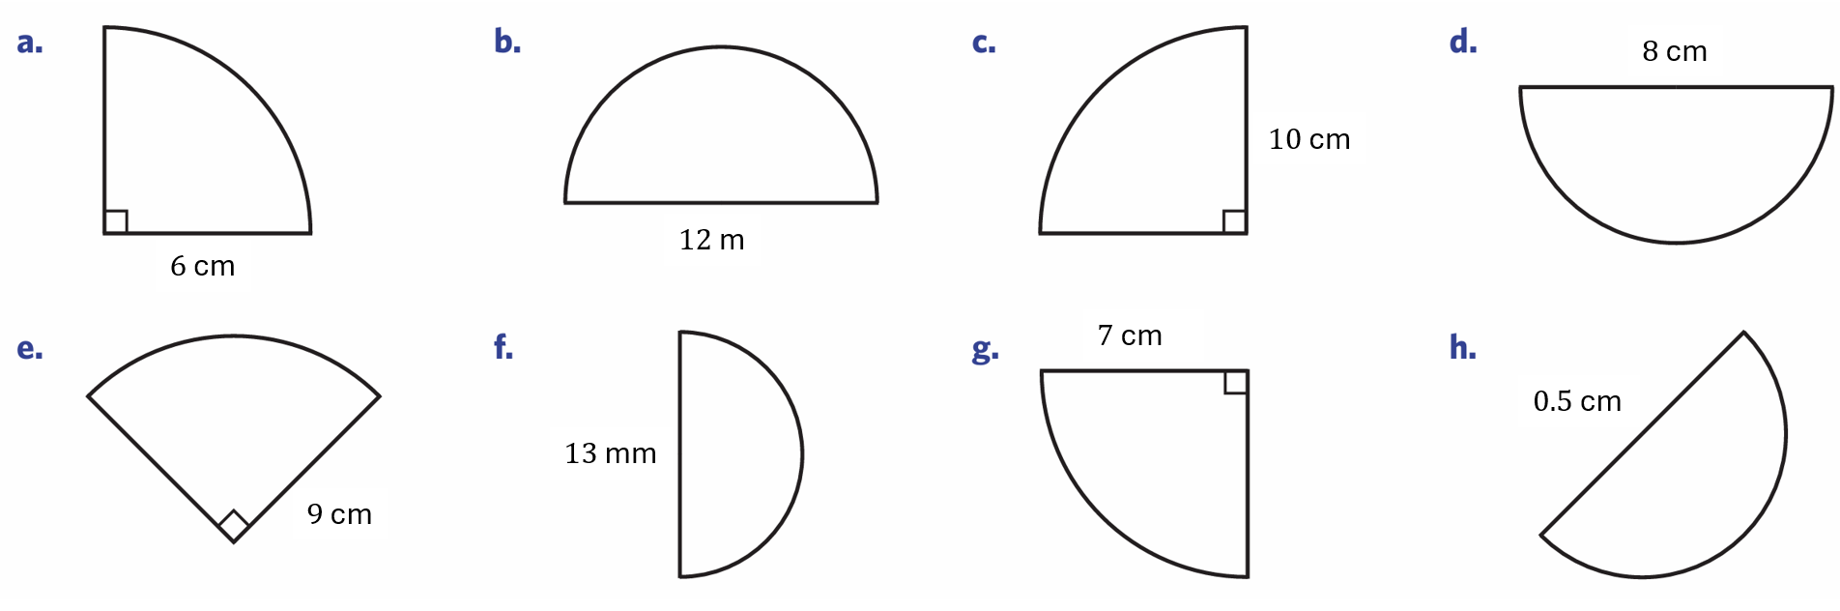  $$A=\frac{π{\left(6\right)}^{2}}{4}$$  $$=\frac{36π}{4}$$  $=9π$ cm² | 18π m² | 25π cm² | 8π cm²
$\frac{81}{4}$ $π$ cm² | $\frac{169}{8}π mm²$ | $$\frac{49}{4}π {cm}^{2}$$ | $$\frac{π}{32} {cm}^{2}$$

- For the sector shown, Jerry calculated the fraction of the circle as $\frac{240}{360}=\frac{2}{3}$.
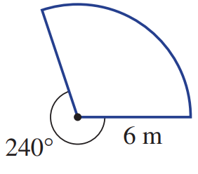
  - Explain why he is wrong.

The angle inside the sector is not 240°
  - Calculate the area of the sector, round to 1 d.p.

37.7 m²
- A shop sells pizza sectors. The two options are:
15 cm radius pizza with an angle of 45° or 26 cm diameter pizza with an angle of 60°.
Which piece gives the bigger area and by how much? Round the answer to two decimal places.

The 60° sector, by around 0.13 cm²
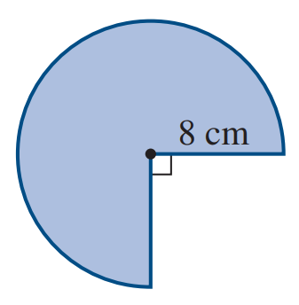
- Calculate the area of the sector shown, answer in terms of $π$.

48π cm²
- Calculate the area of these sectors. The angle shown is the exterior angle.
Round your answers to 1 d.p.
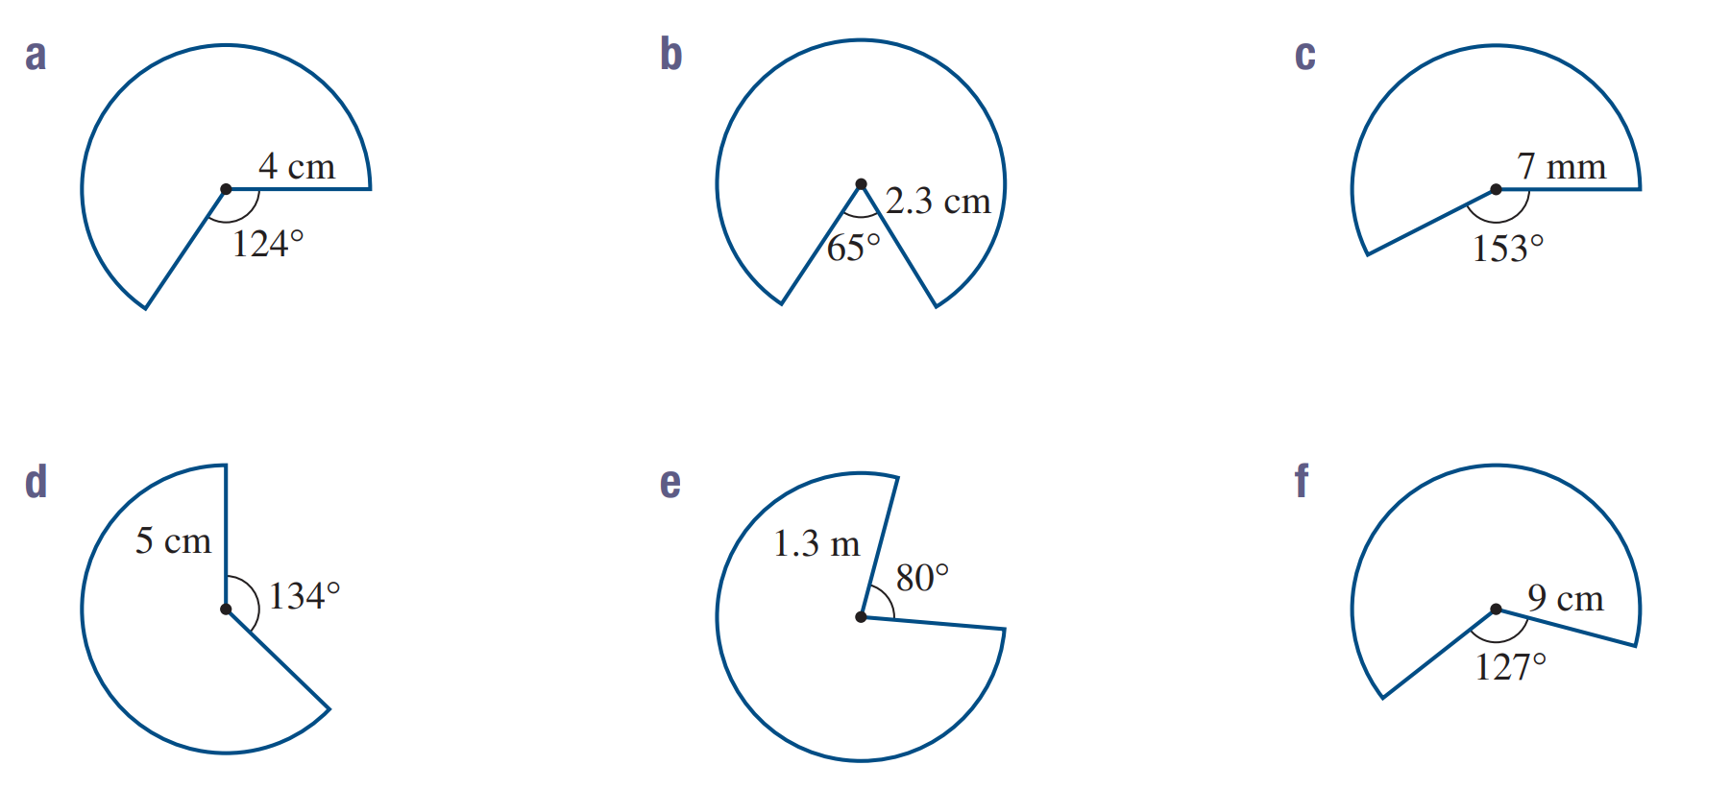  33.0 cm² | 13.6 cm² | 88.5 mm²
49.3 cm² | 4.1 m² | 164.7 cm²

Mixed Practice

Foundation
- Calculate the area of these shapes. Answer to 2 d.p. where appropriate.
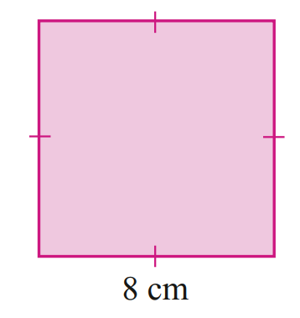  64 cm² | 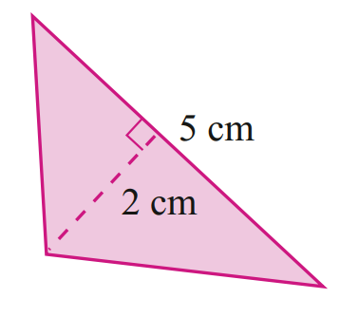  5 cm² | 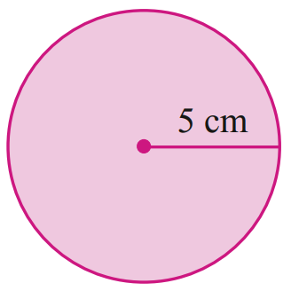  78.54 cm²
254.47 cm² | 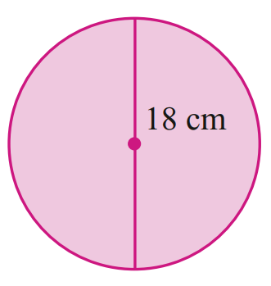  38.11 cm² | 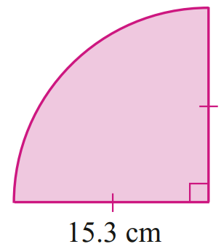  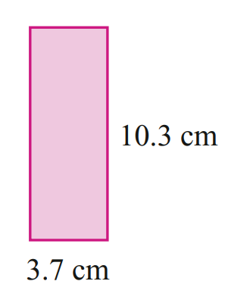  183.85 cm²
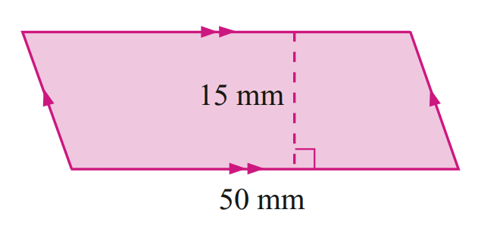  750 cm² | 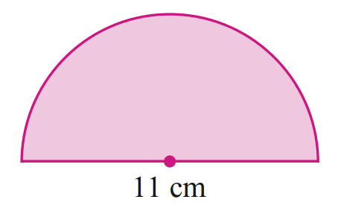  47.52 cm² | 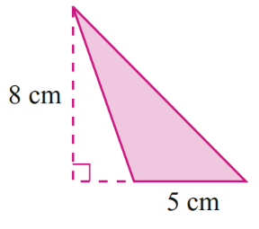  20 cm²
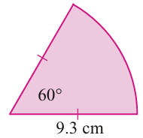  45.29 cm² | 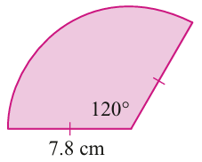  63.71 cm² | 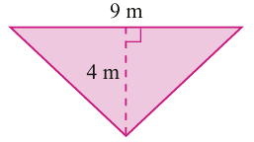  18 cm²

- Calculate the area of these composite shapes.
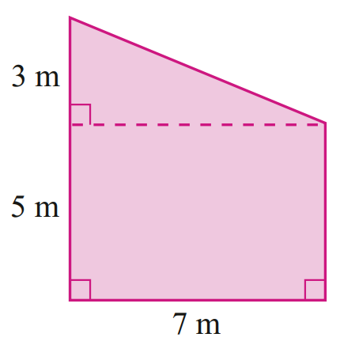  45.5 m² | 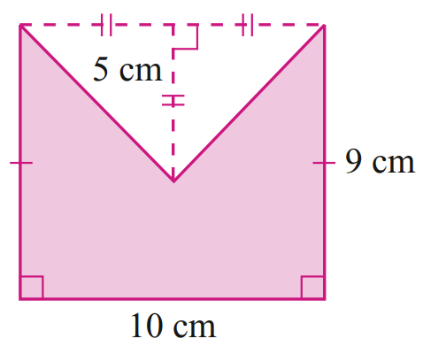  65 cm²

Composite Figures involving Circles

- Area of Composite Figures
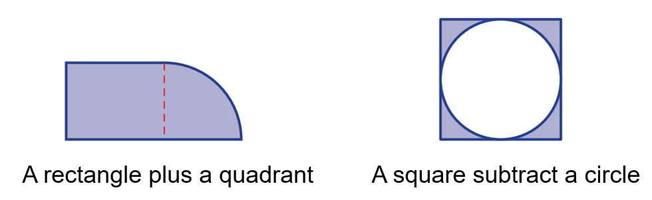
A composite figure is made up of multiple simple shapes.

To find the area of composite figures, add or subtract the areas of simple shapes.
- Split the composite figure into simpler shapes.
- Calculate the area of each simple shape.
- Add or subtract the areas.

- Example Calculate area of composite shapes involving circles
Calculate the shaded area to two decimal places.
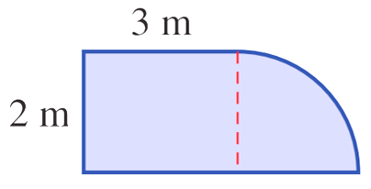
$$A_{1}$$

$$A_{2}$$

$A_{1}=2×3$  $=6$ m² | $$A_{2}=\frac{1}{4}π{\left(2\right)}^{2}$$  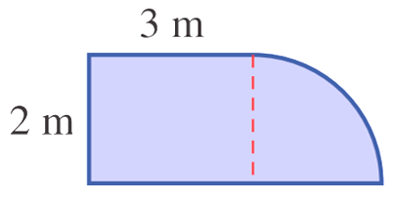  $=3.14$ m^{2s} | $A_{Total}=A_{1}+A_{2}$  $=6+3.14$  $=9.14$ m²

- Guided Practice
Calculate the shaded area. Round your answer to 2 decimal places.
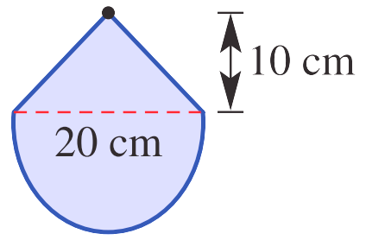  $A_{1}=$  $A_{2}=$  $A_{Total}=$  257.08 cm² | 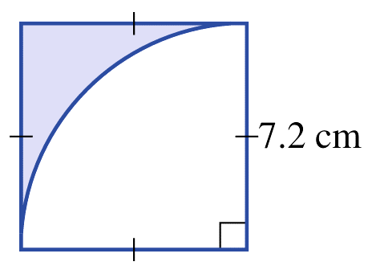  $A_{1}=$  $A_{2}=$  $A_{Total}=$  11.12 cm²

Foundation
- Calculate the areas of these composite shapes using addition. Answer to 2 d.p.
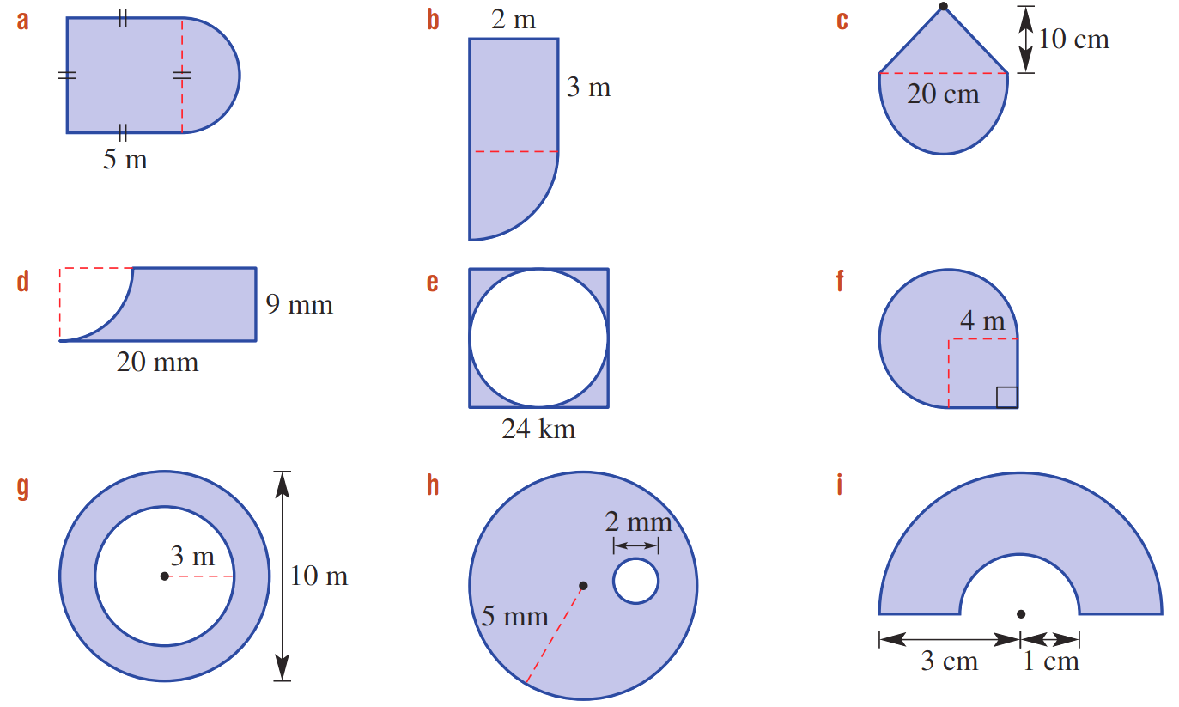  $$A_{1}$$  $$A_{2}$$  $A_{1}=$ ………………  $A_{2}=$ ………………  $A_{Total}=$ $A_{1}+A_{2}$  $=$ ………………  34.82 m² | 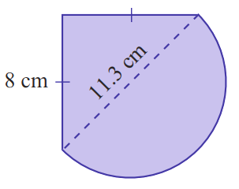  82.14 cm²
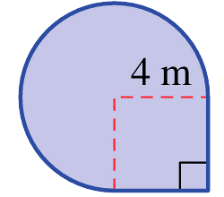  53.70 m² | 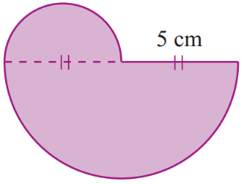  49.09 cm²
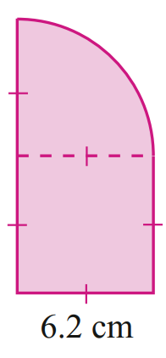  68.63 cm² | 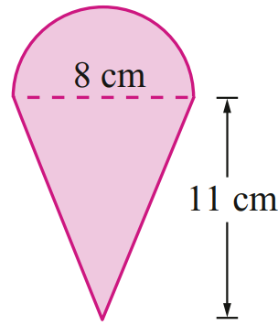  69.13 cm²
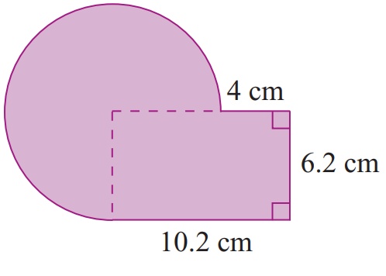  153.81 cm² | 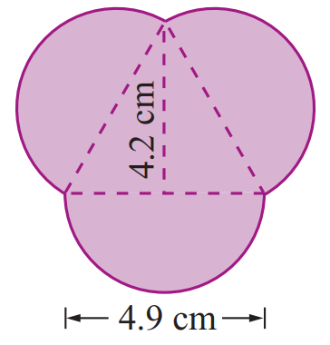  38.58 cm²

- Calculate the areas of these composite shapes using subtraction.
116.38 mm² | 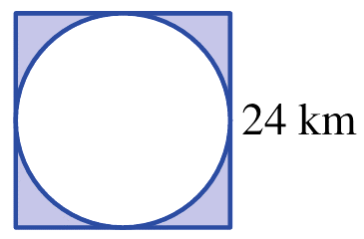  123.61 km²
103.67 cm² | 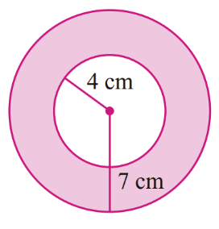  50.27 m²
113.09 cm² | 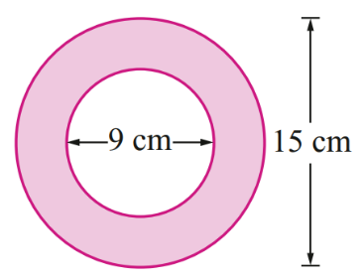  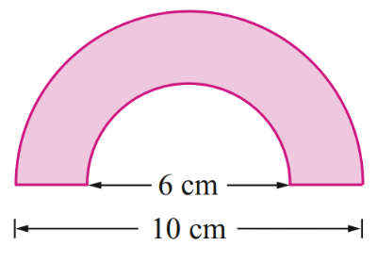  25.13 cm²
23.83 mm² | 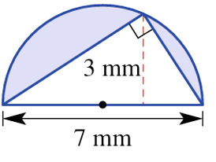  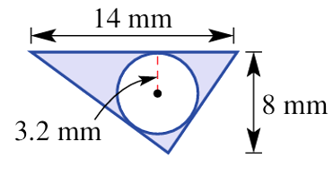  8.74 mm²

Development
- Calculate the area of these shapes. Answer to 2 decimal places.
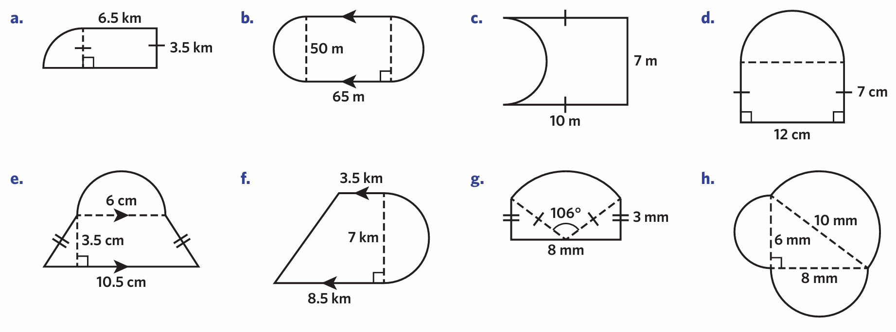  5213.50 m² | 50.76 m² | 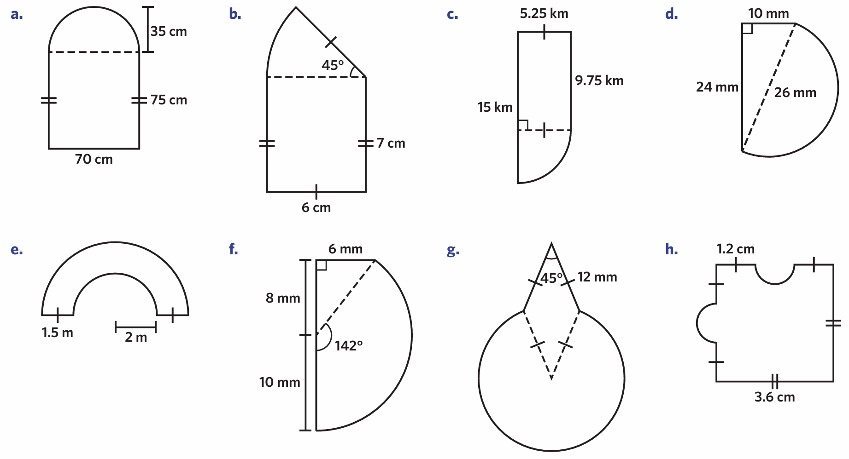  12.96 m²
56.14 cm² | 147.92 mm² | 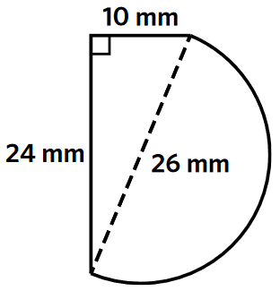  385.46 mm²
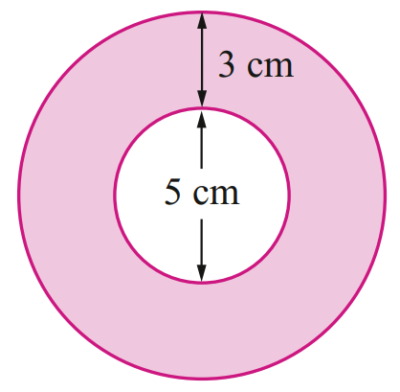  75.40 cm² | 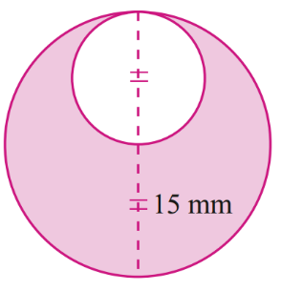  530.14 mm² | 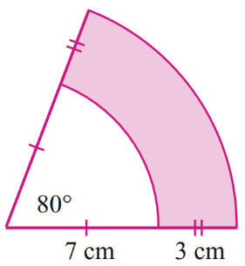  35.60 cm²
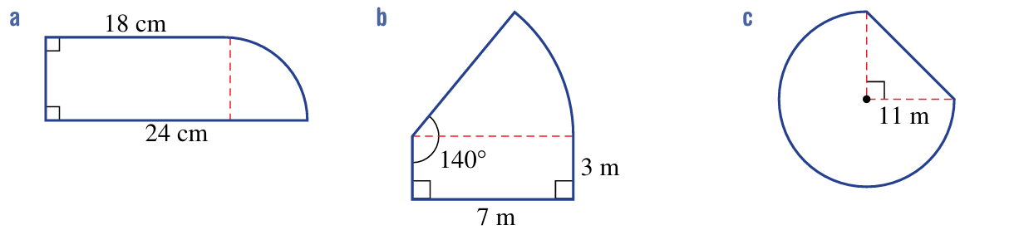  136.27 cm² | 42.38 m² | 345.60 m²

Mastery
- Calculate the shaded area of these shapes.
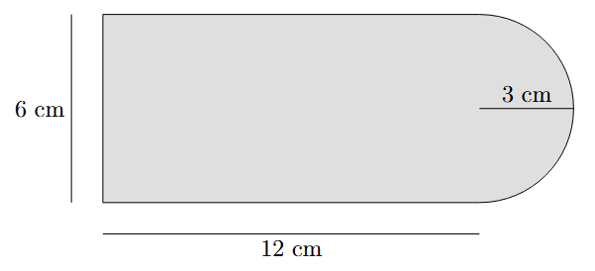  86.14 cm² | 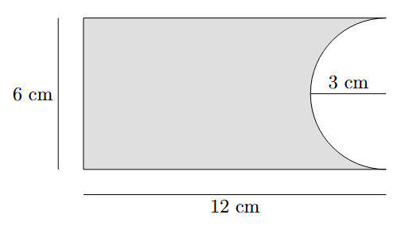  57.86 cm²
Add your areas together. What do you get?

$$86.14+57.86=144$$
This is double the rectangle area.
- 2009 HSC Standard 2 Band 4
What is the area of the shaded part of this shape, correct to the nearest square centimetre?
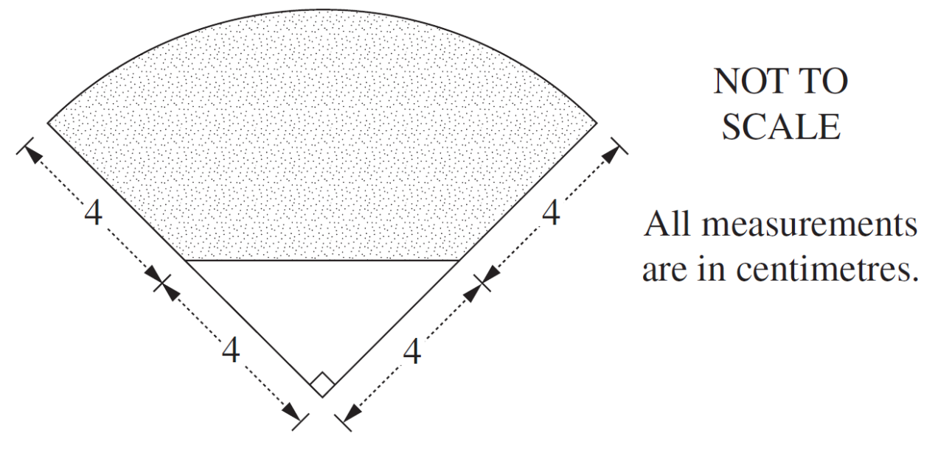

$$\frac{1}{4}π{\left(8\right)}^{2}-\frac{16}{2}$$
= 42.27 cm²
- The racetrack shown needs to be resurfaced.
Calculate the area to be resurfaced to 2 decimal places.
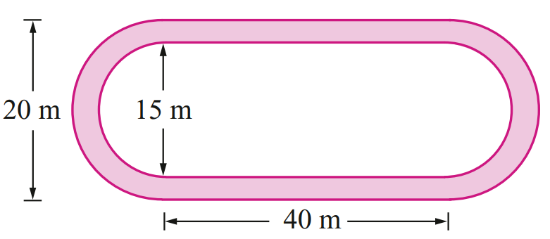

The racetrack is an oval made up of a rectangle and two semicircles.
Area is outer oval – inner oval.
$$A=\left(40×20+π{\left(10\right)}^{2}\right)-\left(40×15+π{\left(7.5\right)}^{2}\right)$$
337.44 m²

- A golf course has a sprinkler system that waters the grass in the shape of a sector, as shown.
A sprinkler is positioned at point $L$ and can turn through an angle of 100°.
The section of grass that is watered is 4.5 m wide at all points.
Water can reach a maximum of 12 m from the sprinkler at $L$.
What is the area of grass that this sprinkler will water?
Round your answer to the nearest square metre.
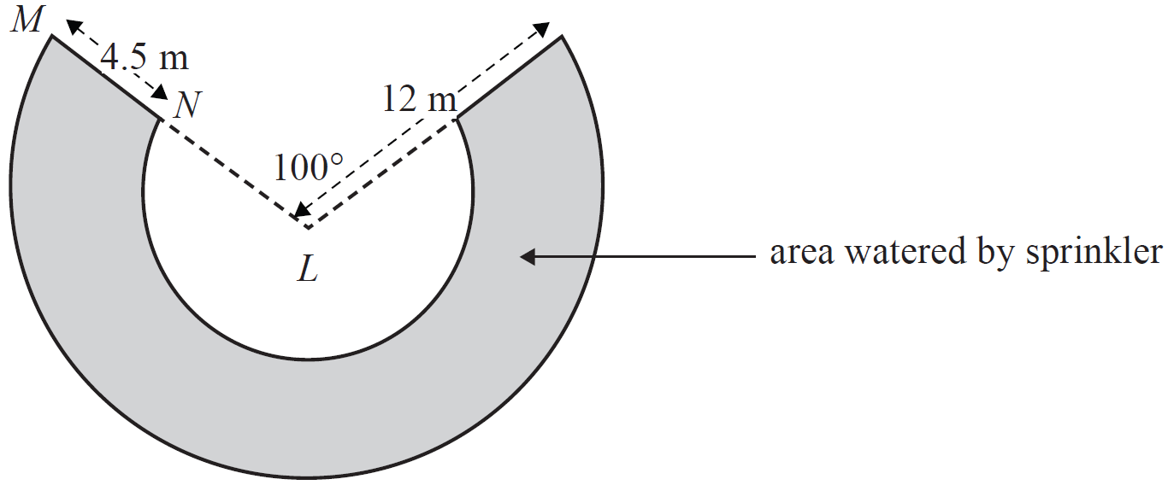

$$A=\frac{260}{360}π{\left(12\right)}^{2}-\frac{260}{360}π{\left(7.5\right)}^{2}$$
= 199 m²
- Find the area of the dark region to 2 d.p.
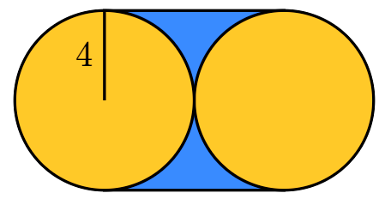

Area of dark region = Square – circle
$8^{2}-π{\left(4\right)}^{2}=13.73$ units²
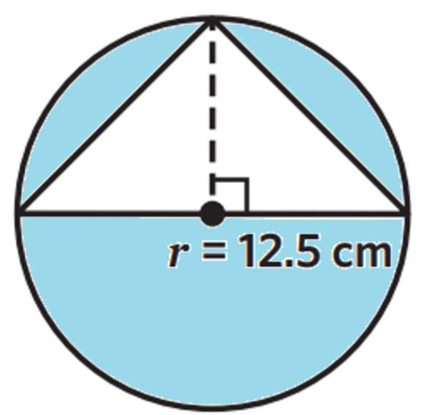
- A triangle is inscribed in a circle, as shown. Calculate the shaded area to 2 d.p.

$$π{\left(12.5\right)}^{2}-\frac{1}{2}\left(25\right)\left(12.5\right)=334.62 {cm}^{2}$$
- Tui has a wall that has a height of 3.5 m and width of 6.5 m.
She has cut an arch into the wall that consists of a semicircle with a diameter of 3.5 m and
a rectangle that is 1.75 m high.
Calculate the area of the wall she has left, correct to 2 decimal places.
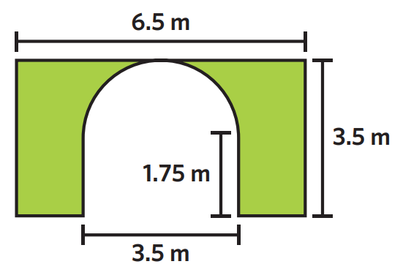

$$3.5×6.5-\left(3.5×1.75\right)-\frac{1}{2}π{\left(1.75\right)}^{2}=11.81 m$$

Finding the Radius Given the Area

- Review
- Solve equations involving $π,$fractions, square roots.
Solve for $r$. Show the answer as a surd and to 1 d.p.
- $36=πr^{2}$ | - $50=πr^{2}$
- $15=$ $\frac{πr^{2}}{2}$ | - $8=$ $\frac{πr^{2}}{4}$
- $10=$ $\frac{50}{360}$ $×πr^{2}$ | - $15=$ $\frac{100}{360}$ $×πr^{2}$

- Area of Circles
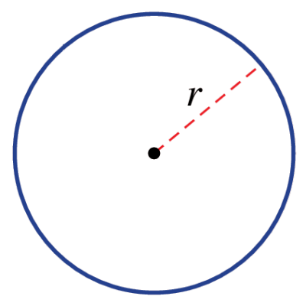  Circle | 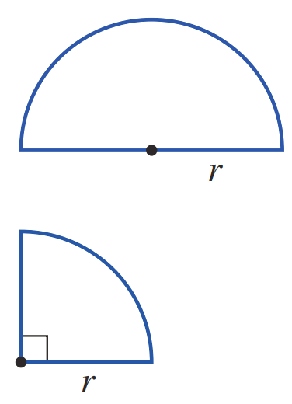  Quadrant | Semicircle | Sector
$$A=πr^{2}$$ | $$A=\frac{πr^{2}}{4}$$ | $$A=\frac{πr^{2}}{2}$$ | $$A=\frac{θ}{360}πr^{2}$$
Steps for using any formula:
1. Write the formula.
2. Substitute given values.
3. Solve for the unknown value using inverse operations.

- Example Solve for the radius, given the area
Example | Your Turn
The area of a semicircle is $A=25 m^{2}$  Find the radius to 3 d.p.  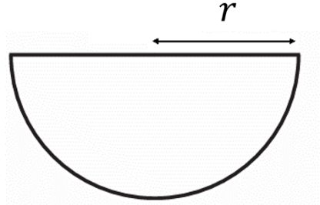  1. Write the formula $A=$ $\frac{πr^{2}}{2}$2. Substitute $25=$ $\frac{πr^{2}}{2}$3. Solve $×2 ×2$  $50=πr^{2}$  $÷π ÷π$  $\frac{50}{π}$ $=r^{2}$  $\sqrt{\frac{50}{π}}$ $=r$  $3.989$ cm $=r$ | The area of a semicircle is $A=20 m^{2}$  Find the radius to 3 d.p.  1.  2.  3.  3.568 m

- Guided Practice
- The area of a circle is $75$ cm²  Find the radius to 3 d.p.  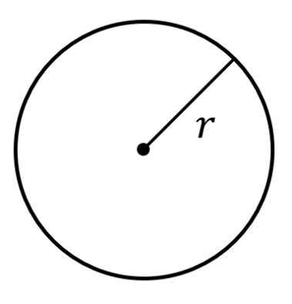  4.886 cm | - The area of a quadrant is $A=13.5$ m²  Find the radius to 3 d.p.  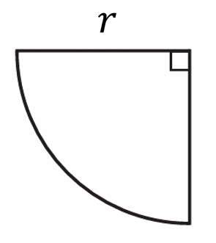  4.146 m
- The area of this sector is 30 m²  Find the radius to 3 d.p.  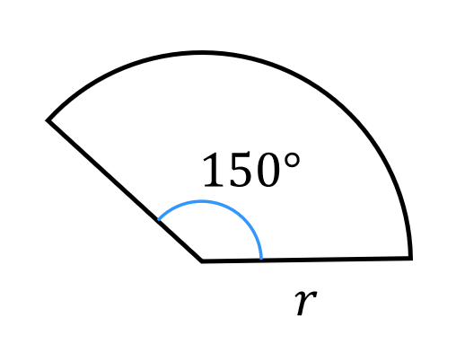  4.787 m | - The area of this sector is 60 cm²  Find the interior angle to the nearest degree.  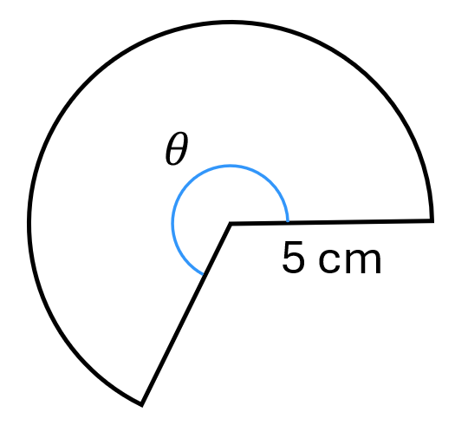  275°

Foundation
- Calculate the radius of each circle, rounding your answer to 1 d.p.
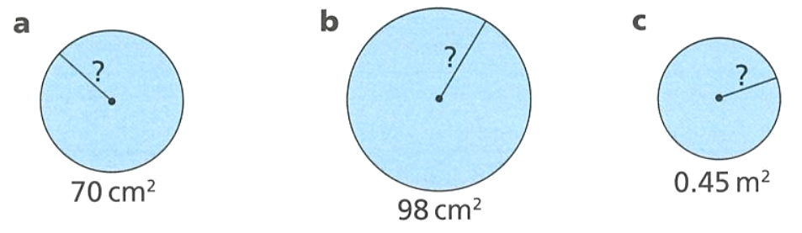  - $A=70$ cm²  $A=πr^{2}$  $70=πr^{2}$  $$\frac{70}{π}=r^{2}$$  $$\sqrt{\frac{70}{π}}=r$$  ………… $=r$  $$4.7 cm$$ | - $A=98$ cm²  $A=πr^{2}$  5.6 cm | - $A=0.45$ m²  0.4 m

- Calculate the radius of each semicircle or quadrant, rounding your answer to 2 d.p.
- $A=15.5$ mm²  $$A=\frac{πr^{2}}{2}$$  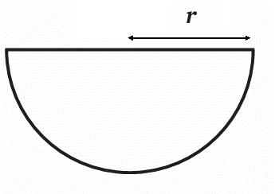  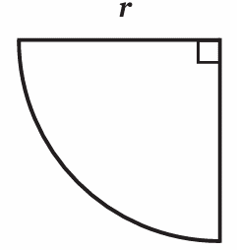  3.14 mm | - $A=14.8$ cm²  3.07 cm
- $A=6$ mm²  $$A=\frac{πr^{2}}{4}$$  2.76 mm | - $A=3.8$ cm²  2.20 cm

- Find the diameter for these areas, rounding your answer to 1 d.p.
(Find the radius, then multiply by 2)
- $A=12$ cm²  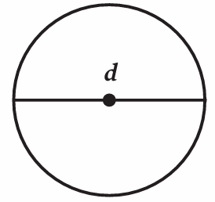  3.9 cm | 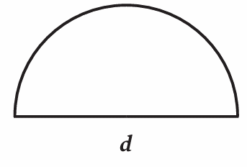  - $A=14$ mm²  6.0 mm

- Read the example for when the area is given in terms of $π$ and answer the questions.
- The area of a circle is $25π$ cm².  Calculate the radius.  $$A=πr^{2} \\ 25π=πr^{2} \\ ÷π=÷π \\ 25=r^{2} \\ \sqrt{}=\sqrt{} \\ 5=r$$  The radius is 5 cm. | - The area of a circle is $9π cm^{2}$  Calculate the radius.  $A=πr^{2}$  $9π=πr^{2}$  $9=r^{2}$  … $=r$  3 cm | - The area of a circle is $100π cm^{2}$  Calculate the radius.  10 cm
- The area of a semicircle is $32π cm^{2}$  Calculate the radius.  8 cm | - The area of a quadrant is $9π cm^{2}$  Calculate the radius  6 cm | - The area of a quadrant is $23π cm^{2}$  Calculate the radius to  1 d.p.  9.6 cm

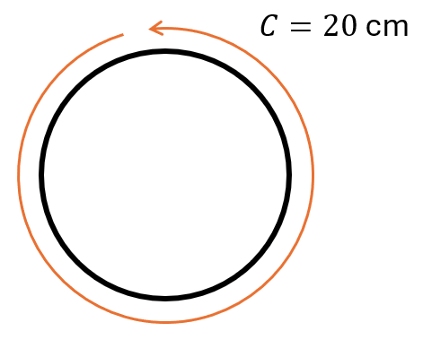
- Ferdinand measures the circumference of his circular plate to be 20 cm.

- What is the radius of the plate? (circumference is $C=2πr$)  3.183 cm | - What is the area that his plate covers?  31.83 cm²

Development
- Complete the table.
 | Radius | Diameter | Area $A=πr^{2}$  (in terms of $π$) | Circumference $C=2πr$  (in terms of $π$)
 | 3 | 6 | $$9π$$ | $$6π$$
 | 6 | 12 | $$36π$$ | $$12π$$
 | 6 | 12 | $$36π$$ | $$12π$$
 | 2 | 4 | $$4π$$ | $$4π$$
 | 1 | 2 | $$π$$ | $$2π$$
 | 4 | 8 | $$16π$$ | $$8π$$
 | 8 | 16 | $$64π$$ | $$16π$$
 | $$\frac{2}{3}$$ | $$\frac{4}{3}$$ | $$\frac{4π}{9}$$ | $$\frac{4π}{3}$$
 | $$\frac{3}{10}$$ | $$\frac{3}{5}$$ | $$\frac{9π}{100}$$ | $$\frac{3π}{5}$$
 | $$\frac{2}{5}$$ | $$\frac{4}{5}$$ | $$\frac{4π}{25}$$ | $$\frac{4π}{5}$$
 | $$\frac{2}{25}$$ | $$\frac{4}{25}$$ | $$\frac{4π}{625}$$ | $$\frac{4π}{25}$$

- NAPLAN A
The radius of a circle is 6.5 centimetres.
A square has the same area as this circle.
Calculate the side length of the square, in centimetres correct to one decimal place.

$$A=π{\left(6.5\right)}^{2}$$
$$l=\sqrt{π{\left(6.5\right)}^{2}}$$
11.52 cm

- Fill in the table.
 | Sketch | Radius | Angle | Fraction of circle | Circum-ference | Arc Length | Area of circle | Area of sector
 | 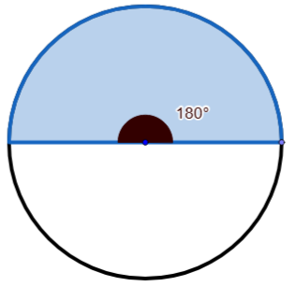 | 6 | 180$°$ | $$\frac{1}{2}$$ | $$12π$$ | $$6π$$ | 36π | 18π
 | 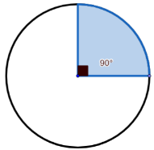 | 6 | 90° | $$\frac{1}{4}$$ | 12π | 3π | 36π | 9π
 |  | 6 | 45$°$ | $$\frac{1}{8}$$ | $$12π$$ | 1.5π | 36π | 4.5π
 |  | 6 | 270° | $$\frac{3}{4}$$ | 12π | 9π | 36π | 27π
 |  | 6 | 60° | $$\frac{1}{6}$$ | 12π | $$2π$$ | 36π | 6π
 |  | 6 | 120° | $$\frac{1}{3}$$ | 12π | 4π | $$36π$$ | $$12π$$
 |  | 6 | $$330°$$ | $$\frac{11}{12}$$ | $$12π$$ | 11π | 36π | 33π
 |  | 12 | $$330°$$ | $$\frac{11}{12}$$ | $$24π$$ | 22π | 144π | 132π
 |  | 12 | 30° | $$\frac{1}{12}$$ | $$24π$$ | $$2π$$ | 144π | 12π
 |  | 12 | 90° | $$\frac{1}{4}$$ | 24π | $$6π$$ | 144π | $$36π$$

Mastery

- Calculate the exact circumference of a circle with diameter 5 cm.  $5π$ cm | - Calculate the exact area of a circle with diameter 5 cm.  $\frac{25π}{4}$ cm
- The area of a circle is 48 cm².  Calculate the radius of the circle to 1 d.p.  $3.9$ cm | - The circumference of a circle is 48 cm. Calculate the area to 1 d.p.  $183.4$ cm²
- 2017 HSC Standard 2 Band 5
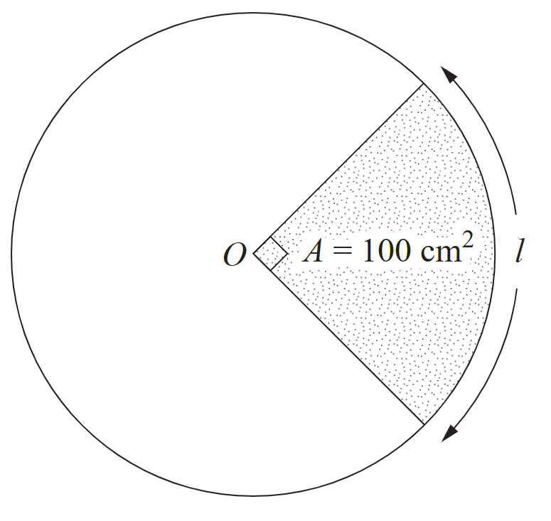
In the circle, the area of the quadrant is 100 cm².
What is the arc length $l$, correct to one decimal place?

$$100=\frac{1}{4}πr^{2}$$
$$r=11.283 cm$$
$$l=\frac{1}{4}\left(2πr\right)=17.7 cm$$

- Consider the sector below. It is not drawn to scale.
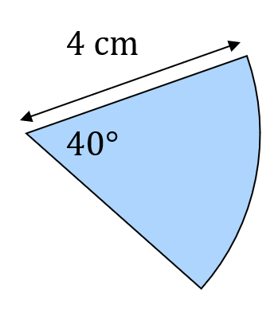  - Calculate the area of the sector to 2 d.p.  5.59 cm² | - Calculate the perimeter to 2 d.p.  10.79 cm
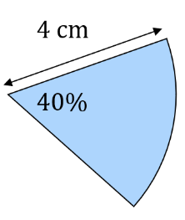  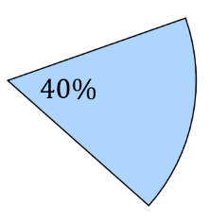  - The sector is 40% of the circle.  Calculate the area of the sector.  20.11 cm² | - The sector is 40% of the circle and has an area of 200 cm². Calculate the area of the whole circle.  $$0.4×A=200$$  $∴A=$ 500 cm²
- Find the unknown value in these sectors.
- The area is 16 cm².  Find the radius to 2 d.p.  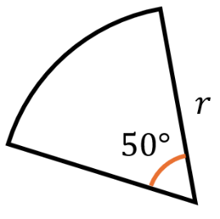  $$A=\frac{θ}{360}πr^{2} \\ 16=\frac{50}{360}πr^{2} \\ 16=\frac{5}{36}πr^{2} \\ ×36=×36 \\ 576=5πr^{2} \\ ÷5π=÷5π \\ \frac{576}{5π}=r^{2} \\ \sqrt{}=\sqrt{} \\ 6.06 cm=r$$ | 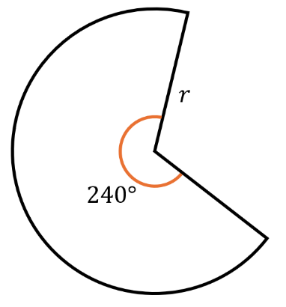  - The area is $105.6$ cm².  Find the radius to 1 d.p.  7.1 cm | - $A=323$ cm²  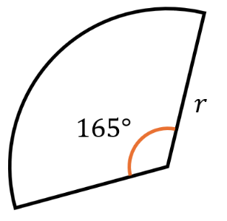  Find diameter to 2 d.p.  29.95 cm
- The area is 335.1 cm².  Find the angle.  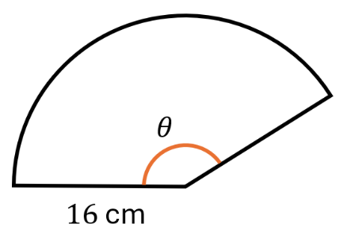  150° | - The area is 272.7 cm²  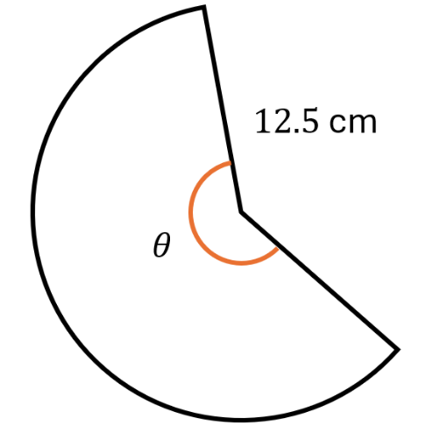  Find the angle.  200° | 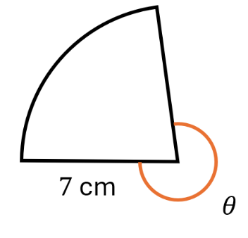  - The area is 32.07 cm²  Find the outside angle.  285°

Challenge Exercise
- Anastasia sells pizzas for $24. Her pizzas have a radius of 18 cm.
She is creating a new pizza size that has a radius of 21 cm.
How much should she sell the new size so her customers pay the same amount per cm²?

Current $/cm²: $\frac{\$24}{π{\left(18\right)}^{2}}$ $=\$0.02357851009/{cm}^{2}$
New area: $π{\left(21\right)}^{2}=1385.44236$cm²
New price = $1385.44236 {cm}^{2}×\$0.02357851009/{cm}^{2}$
$$=\$32.67$$

Alternate method
new pizza is ${\left(\frac{21}{18}\right)}^{2}$ as large.
$$\$24×{\left(\frac{21}{18}\right)}^{2}=\$32.67$$

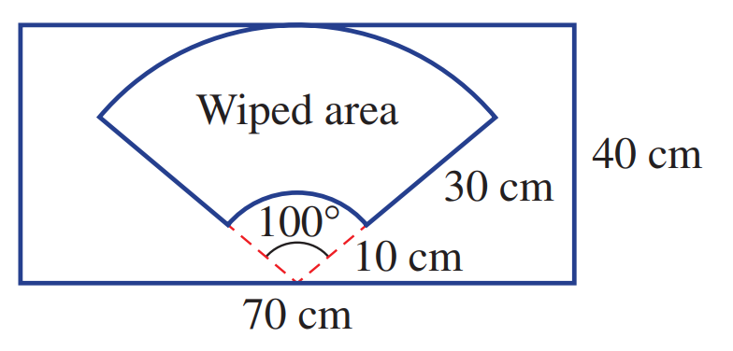
- Determine the percentage of the windscreen covered by the wiper to 2 d.p.

$$\frac{\frac{100}{360}π\left({40}^{2}\right)-\frac{100}{360}π{\left(10\right)}^{2}}{40×70}×100=46.75\%$$
- The floor in an art gallery is to be painted. The diagram shows the region to be painted.
A tin of paint covers 6.5 m².
Each tin of paint costs $12.95.
Determine the cost of painting the floor.
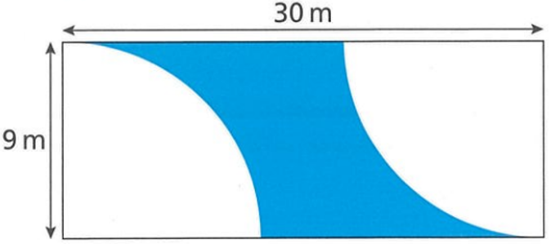

$$Area=30×9-2×\left(\frac{1}{4}π{\left(9\right)}^{2}\right)=142.765 m^{2}$$
Tins of paint needed = $142.765÷6.5≈22$ tins of paint needed
$$22×12.95=\$284.90$$
- Work out the area of the shaded region.
(Hint: use the area of a triangle!)
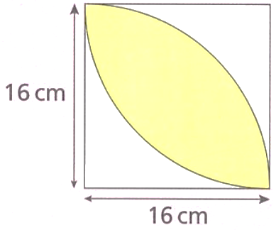

Consider a quadrant. The shaded segment is:
$$Shaded segment =\frac{1}{4}π{\left(16\right)}^{2}-\frac{1}{2}\left(16\right)\left(16\right)=73.06 {cm}^{2}$$
There are two identical segments, so $146.12 {cm}^{2}$

- Find expressions, in simplest form, for the perimeter (P) and area (A) of these shapes.
Answer in terms of $π$; for example, $4π$. Do not use decimals.
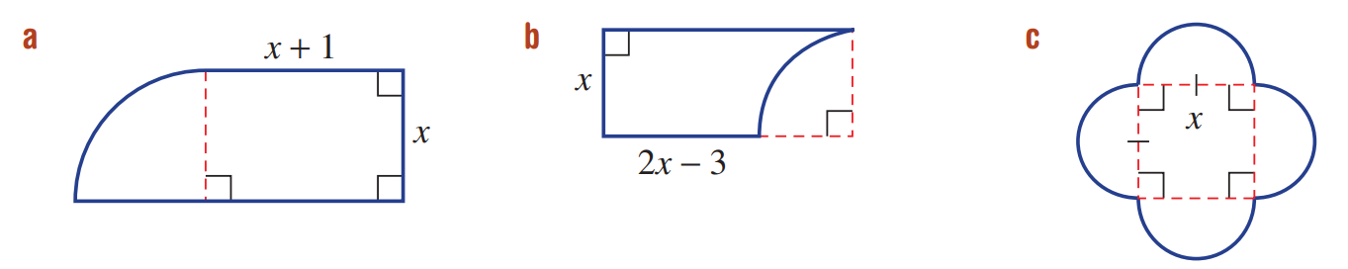  $P=$  $$4x+2+\frac{πx}{2}$$  $A=$  $$x^{2}+x+\frac{πx^{2}}{4}$$ | $P=$  $$6x-6+\frac{πx}{2}$$  $A=$  $$2x^{2}-3x-\frac{πx^{2}}{4}$$ | $P=$  $$4πx$$  $A=$  $$x^{2}+2πx^{2}$$
- Find the area of the composite shape to 2 d.p.

Using right-angled triangle, $r=\sqrt{4^{2}+3^{2}}=5$
$$A=2\left(\frac{1}{2}×3×4\right)+\frac{106}{360}π{\left(5\right)}^{2}$$
= 35.13 mm²
- What fraction of the square is shaded?
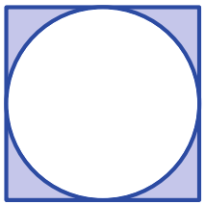

$$\frac{{\left(2r\right)}^{2}-πr^{2}}{{\left(2r\right)}^{2}}=\frac{4r^{2}-πr^{2}}{4r^{2}}=\frac{4-π}{4}$$
- What percentage of the total area is occupied by the shaded region in these diagrams?
Round the answer to one decimal place.
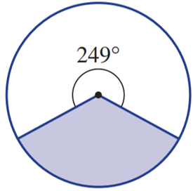  $$\frac{111}{360}×100=30.8\%$$ | 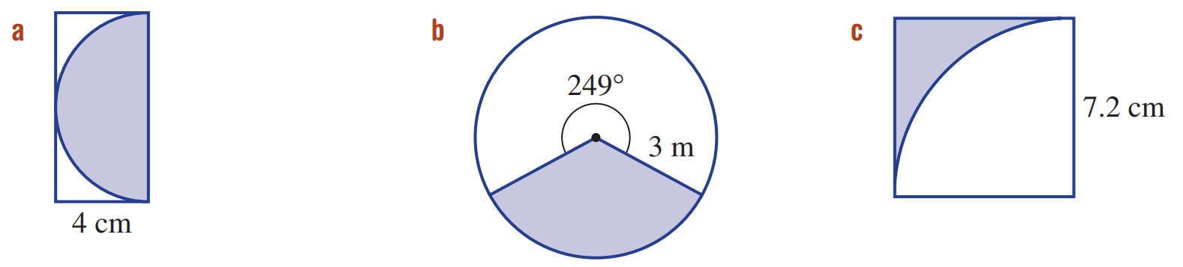  $$\frac{\frac{1}{2}πr^{2}}{2r^{2}}×100$$  $$=\frac{\frac{1}{2}π}{2}×100$$  $$=78.5\%$$ | $$\frac{r^{2}-\frac{1}{4}πr^{2}}{r^{2}}×100$$  $$=\frac{r^{2}\left(1-\frac{1}{4}π\right)}{r^{2}}×100$$  $$=21.5\%$$

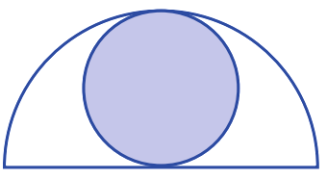
- What percentage of the large semicircle is shaded?

Let radius of small circle be $r$
$$\frac{πr^{2}}{\frac{1}{2}π{\left(2r\right)}^{2}}×100$$
$$=\frac{πr^{2}}{2πr^{2}}×100$$
$$=50\%$$

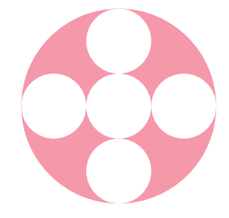
- What percentage of the circle is shaded? Answer to 2 d.p.

Let radius of small circle be $r$
$$\frac{π{\left(3r\right)}^{2}-4πr^{2}}{π{\left(3r\right)}^{2}}×100$$
$$=\frac{5πr^{2}}{9πr^{2}}×100$$
$$=55.56\%$$

- The diagram shows two circles with the same centre.
The radius of the outer circle is equal to the diameter of the inner circle.
If the region between the two circles is divided into six equal segments,
what fraction of the circle is shaded in the diagram?
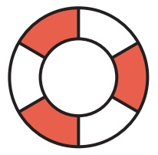

Let inner circle have radius $r$
$$Area of ring:π{\left(2r\right)}^{2}-π{\left(r\right)}^{2}=3πr^{2}$$
Half the ring is shaded, so shaded area = $1.5πr^{2}$
$$\frac{1.5πr^{2}}{4πr^{2}}=\frac{3}{8}$$

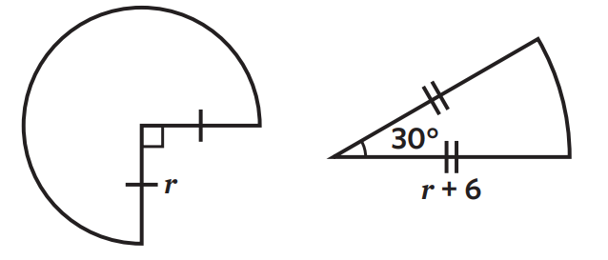
- The shapes in the diagram below have equal areas. Determine the value of $r$.

$$\frac{3}{4}πr^{2}=\frac{1}{12}π{\left(r+6\right)}^{2}$$
$$\frac{3}{4}r^{2}=\frac{1}{12}{\left(r+6\right)}^{2}$$
$$\frac{r^{2}}{{\left(r+6\right)}^{2}}=\frac{1}{9}$$
By trial and error, the radius is 3.
Alternate method using quadratic equations:
$$\frac{3}{4}r^{2}=\frac{1}{12}\left(r^{2}+12r+36\right)$$
This simplifies to $-2r^{2}+3r+9=0$
$$\left(-2r-3\right)\left(r-3\right)=0$$
$$r=3 or-\frac{3}{2}, but r must be positive.$$
$$r=3$$

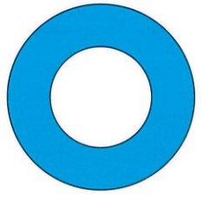
- A shape is made up of two circles with the same centre.
The diameter of the large circle is 12 cm.
The area of the shaded region is 50 cm².
Find the diameter of the smaller circle.

Area of the shaded region is $A=πR^{2}-πr^{2}$
$$36π-πr^{2}=50$$
$$-πr^{2}=50-36π$$
$$r^{2}=\frac{50-36π}{-π}$$
$∴r=4.48$ cm
$$∴diameter of smaller circle is 8.96 cm$$

